Lab task

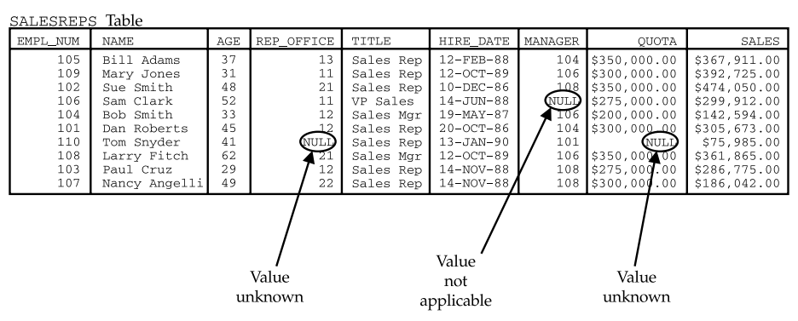

After creation of Table implement queries that given below.

Q1. Select the Empl_Num , Name, Title, Quota and Sales from SalesReps table.

Q2. Select All Employees that have Hire_Date in between Feb-1988 to Nov-1990.

Q3. Select all Employees that have Manager ID 104,108,101 without using OR Operator.

Q4. Select All Employees that have ‘CH’ as Last Character in Name.

Q5. Select Empl_Num, Name, Age, and Title of employees that have ‘A’ as Second Character in their name from SalesReps table.

Q6. Select All Employees that have Email Address on Yahoo mail Server.

Q7. Create a Statement from given table as

“Empl_Num Working as a Job Title Since form Hire_Date with Quota” with field name Employee Statement.

Q8. Select the remaining Sales of employee after Quota Achievement. Label remaining field as ‘Remaining Sales’.

Q9. Show all employees and an order (Ascending, Descending) with EmpI_num.

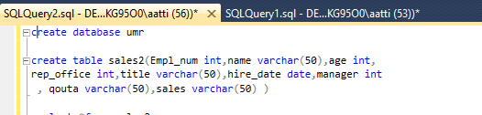

Create database and table with using requirement

**Question 1:**

Select the Empl_Num , Name, Title, Quota and Sales from SalesReps table.

Input:

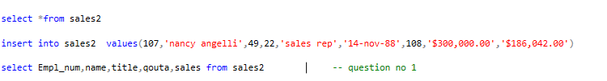

Output

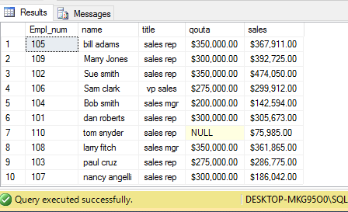

**Question 2:**

Select All Employees that have Hire_Date in between Feb-1988 to Nov-1990.

Input:



Output:

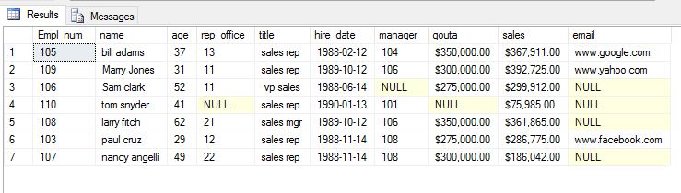

**Question 3:**

Select all Employees that have Manager ID 104,108,101 without using OR Operator.

Input:



Output:

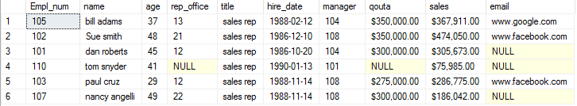

**Question 4**:

Select All Employees that have ‘CH’ as Last Character in Name.

Input:



Output:

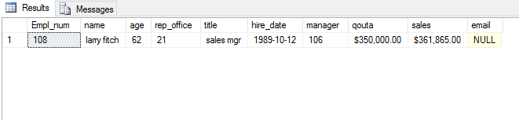

Question 5:

. Select Empl_Num, Name, Age, and Title of employees that have ‘A’ as Second Character in their name from SalesReps table.

Input:



Output:

